Name of issuing company | Carisbrooke Shipping Ltd
Address | Bridge House,  38 Medina Road,  Cowes,  Isle of Wight,  United Kingdom  PO31 7DA
Company contact details | Personnel Department  +44 1983 284 100  vectis@carisbrooke.co
Maritime and Coastguard Agency (MCA) approval number | 004778
This is to certify that:

Name of seafarer/holder
Date of birth | dd / mm / yyyy
Discharge Book number or other national ID

Has met the requirements laid down in Regulation II/4 (Deck) of the STCW Convention 1978, as amended, and the standards of competence specified in section A-II/4 of the STCW Code 1978, as amended, and is competent to serve as a Rating forming part of a Navigational Watch on a seagoing ship of 500 GT or more.

This certificate is issued under the authority of the Maritime and Coastguard Agency of the United Kingdom of Great Britain and Northern Ireland, an executive agency of the Department for Transport.

Company Authorised Representative:

Full Name ………………...…………………… | Signature ………………...……………………
Date …… / …… / ………… | 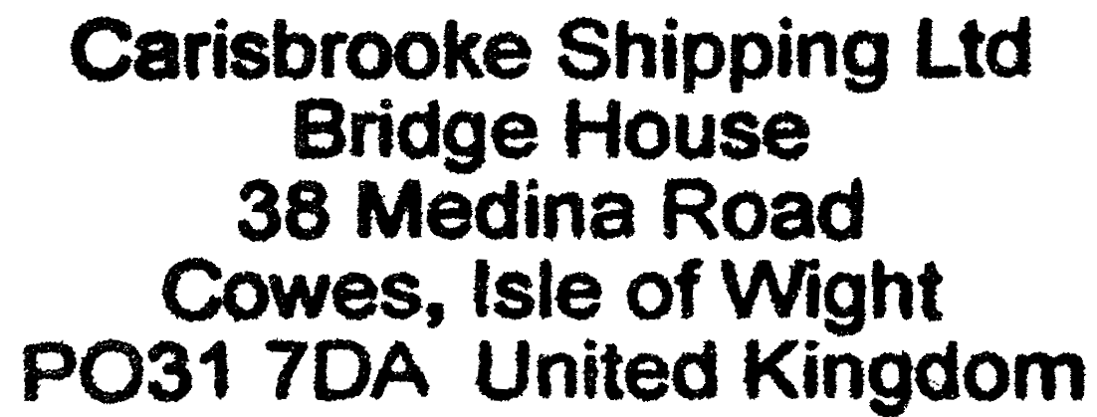  Stamp
Certificate Holder (Rating):

Full Name ………………...…………………… | Signature ………………...……………………
Date …… / …… / …………

